CS 255 System Design Document

UML Diagrams

UML Use Case Diagram

The UML use case diagram illustrates the interactions between the primary users of the DriverPass system and the system itself. The primary actors include Students, Instructors, and Administrators. Students can create accounts, log in, take practice exams, schedule driving lessons, and make payments. Instructors can manage their lesson availability and view scheduled sessions. Administrators can manage user accounts, update practice test questions, and oversee system operations. This diagram ensures that all system functionality aligns with the client’s business requirements.

UML Activity Diagrams

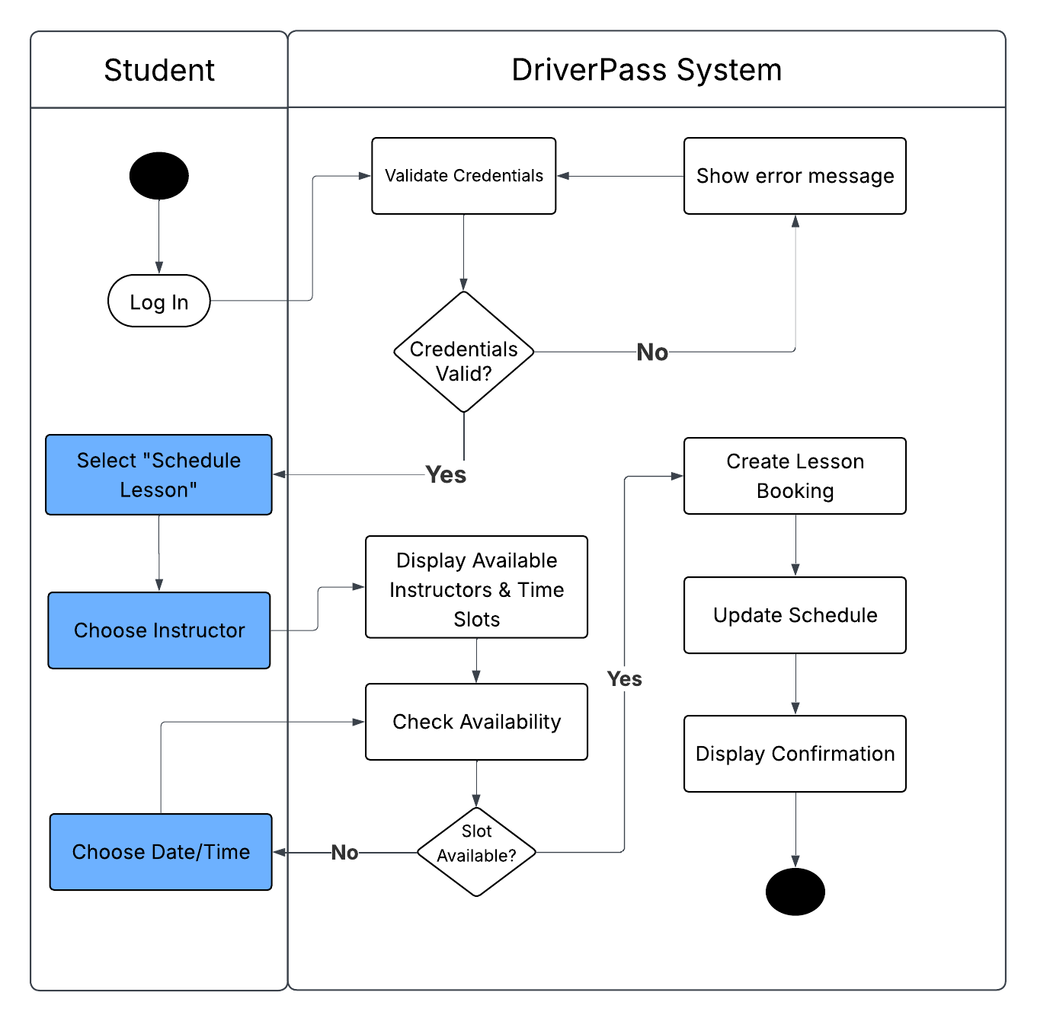

UML Sequence Diagram

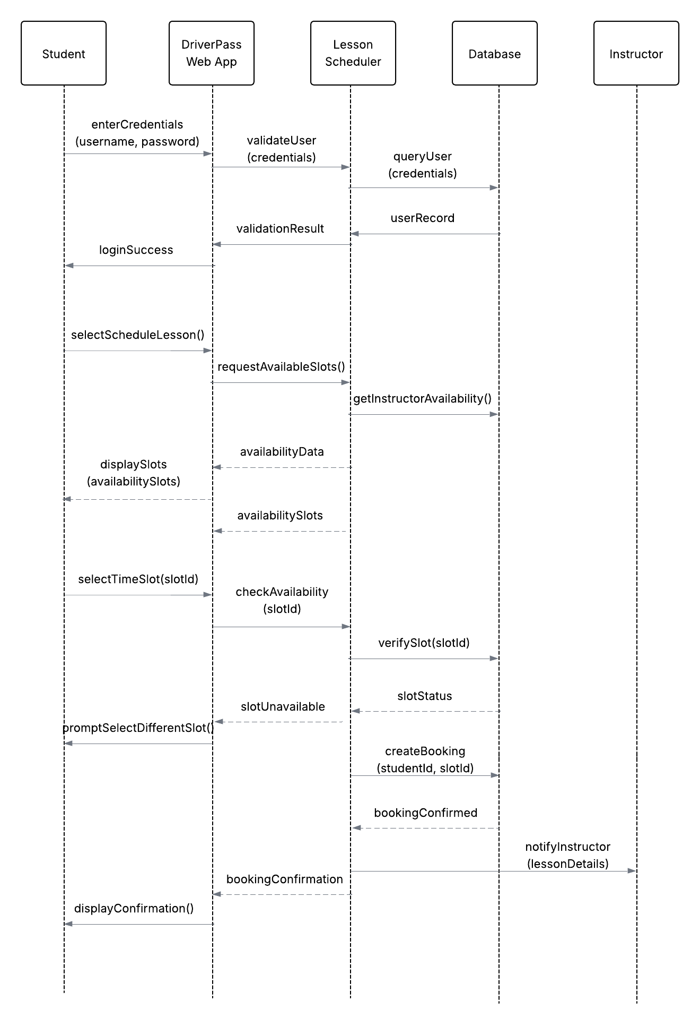

UML Class Diagram

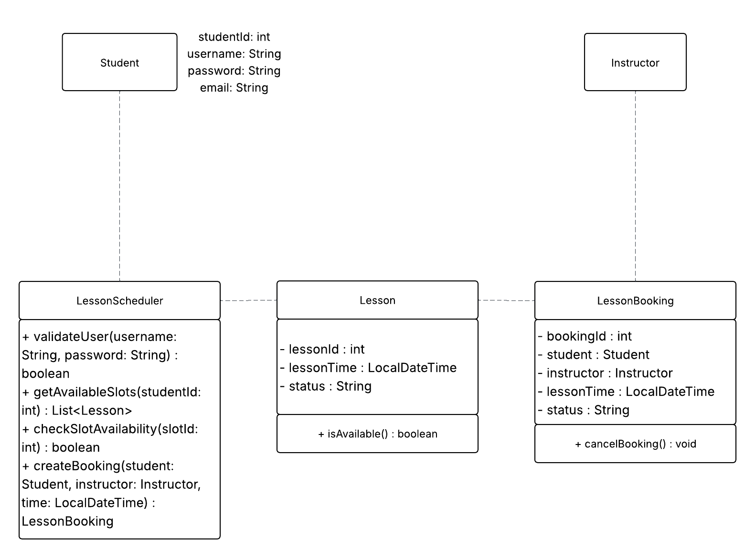

The UML class diagram represents the core structural components of the DriverPass system. The Student and Instructor classes store identifying user information. The Lesson class represents available driving lesson time slots and their status. The LessonBooking class links a student to a specific instructor and lesson time once a booking is confirmed. The LessonScheduler class contains the system logic responsible for validating users, retrieving available lesson slots, checking availability, and creating bookings. These classes work together to support the scheduling functionality described in the activity and sequence diagrams.

Technical Requirements
The DriverPass system will require a web-based application architecture accessible through modern web browsers. The system will require a server capable of handling user authentication, lesson scheduling logic, and practice exam processing. A relational database management system (such as MySQL or PostgreSQL) will be required to store user accounts, lesson schedules, bookings, and practice exam data. The application will require secure HTTPS communication and encryption for protecting user credentials and payment information. The system should be deployable on a cloud-based infrastructure environment to ensure scalability and reliability. Administrative users will require secure role-based access control to manage content, users, and training packages.

